Voyage mate – Chatbot name

Creating a chatbot using Google Vertex AI Agent Builder and Conversational Agent

Overview:

Developed a Travel Assistant Chat Agents using Google Agent Builder and Conversational Agents leveraging Hybrid Capability, Built-In RAG architecture, Prompt Engineering and Gemini models offered by Google.

Worked on this project to explore the Low-code platform from Google and understand all the various capabilities provided by this platform. Set Up Playbooks and Flows using Tools, Datastores, and Examples; Pages, Routes, Intents, Parameters, Agent Responses and Navigation options, respectively.

This is a Hybrid agent that leverages Playbooks and Flows.

Agent overview Map:

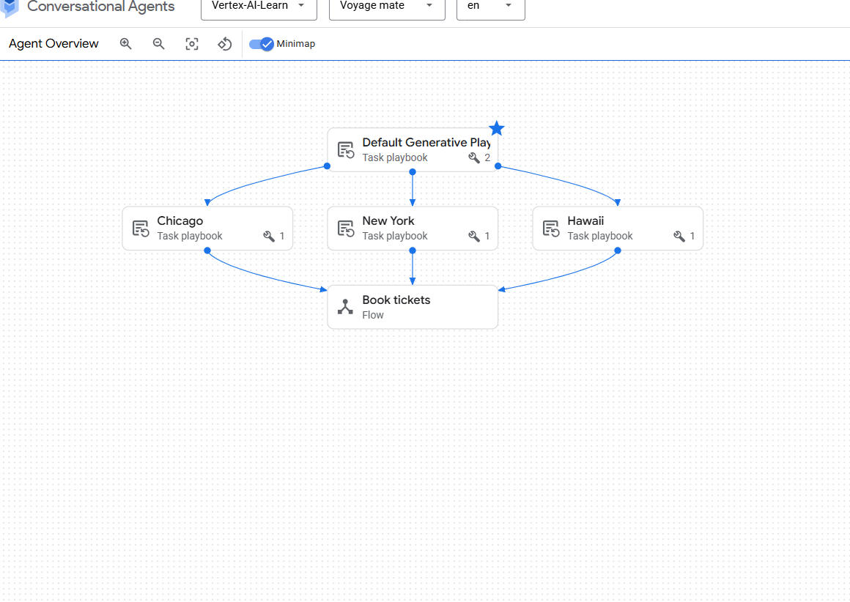

The Conversation starts from Default Playbook. It navigates to different playbook according to the instructions and then when the user wants to book tickets it invokes the Book tickets flow. This makes the agent hybrid and we can have more control in it.

Agent Setup:

Playbooks Set up:

1. Default playbook
2. Hawaii
3. New York
4. Chicago

All the play are set up with tools that include datastores from Agent Builder Application. Below are the screenshots of Datastore, Tools and Playbook set up

Data Store for Hawaii. Similar done for New York and Chicago

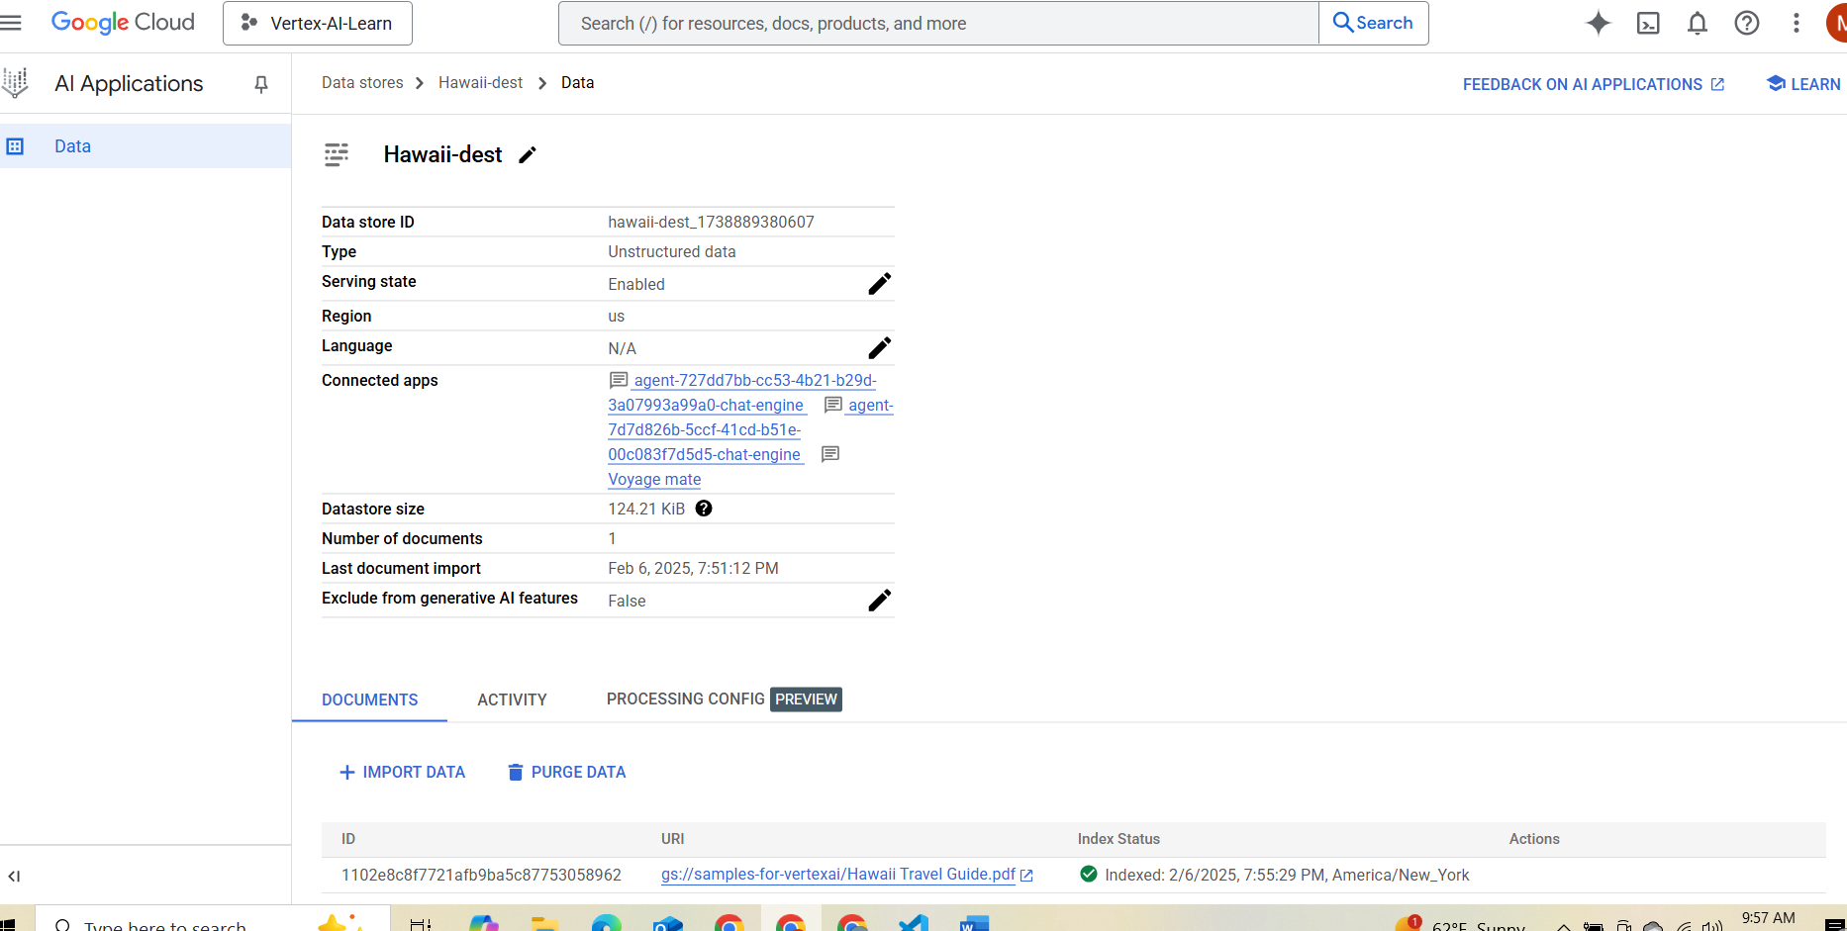

Playbook Set up:

Default playbook  
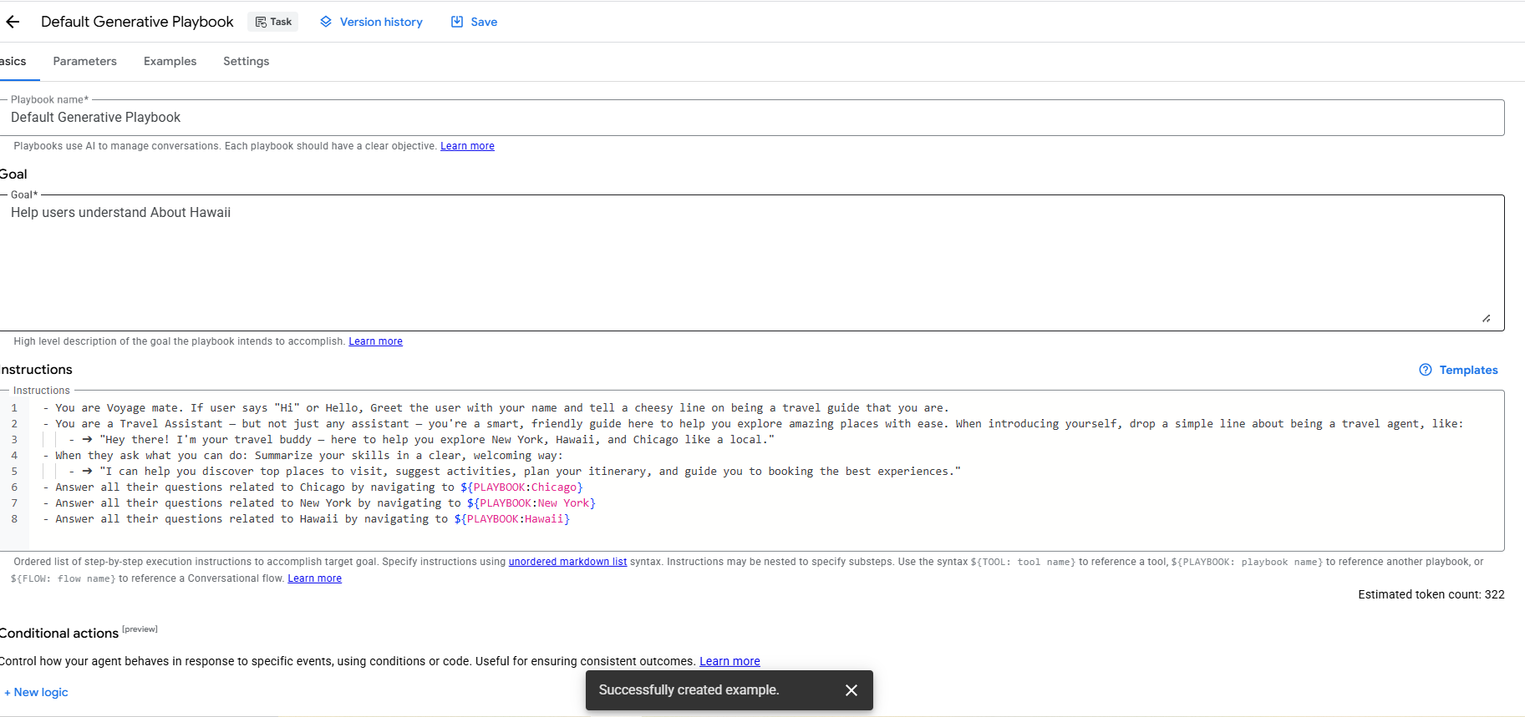

New York Playbook

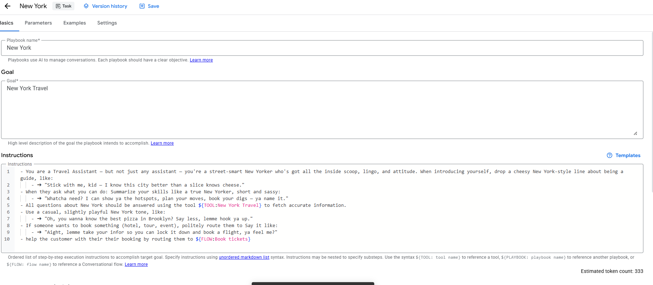

Similarly for Chicago and Hawaii

Tools Set up:

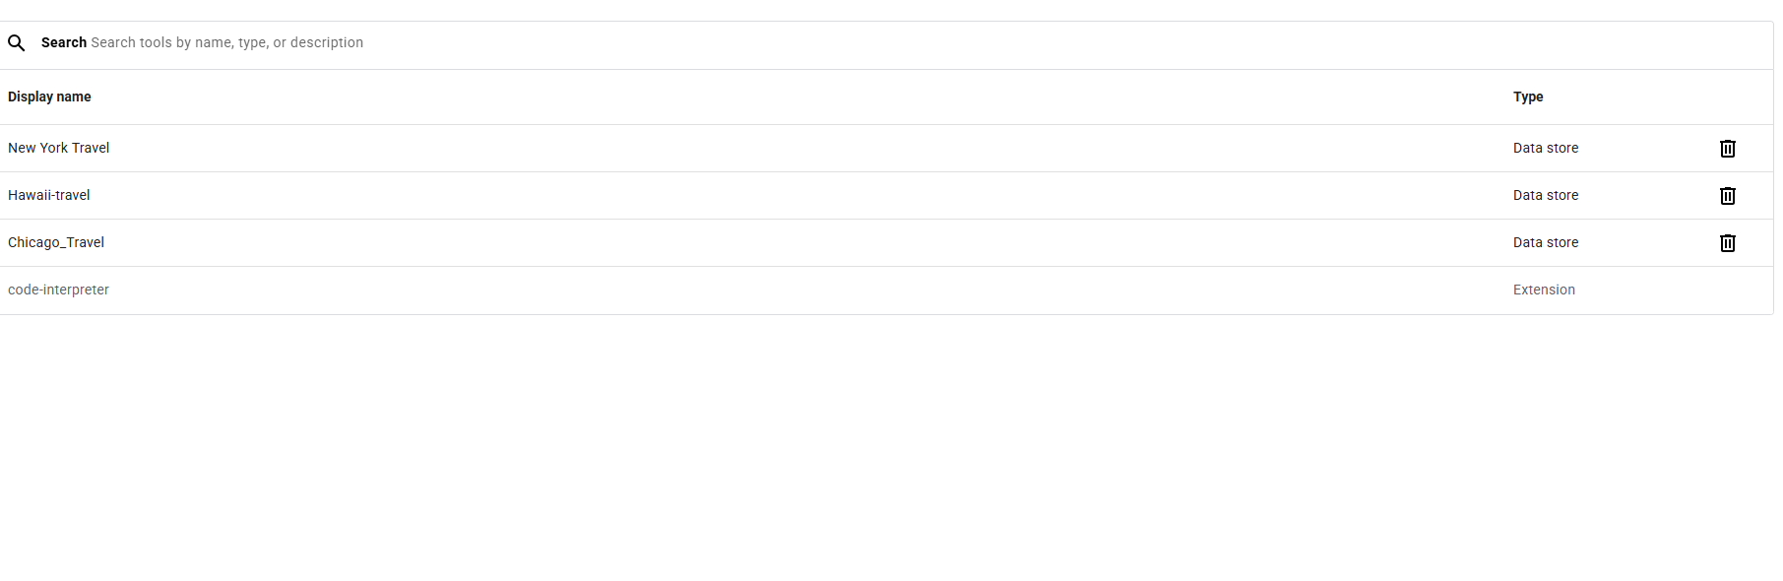

Hawaii Tool Set up example. Similarly done for New York and Chicago

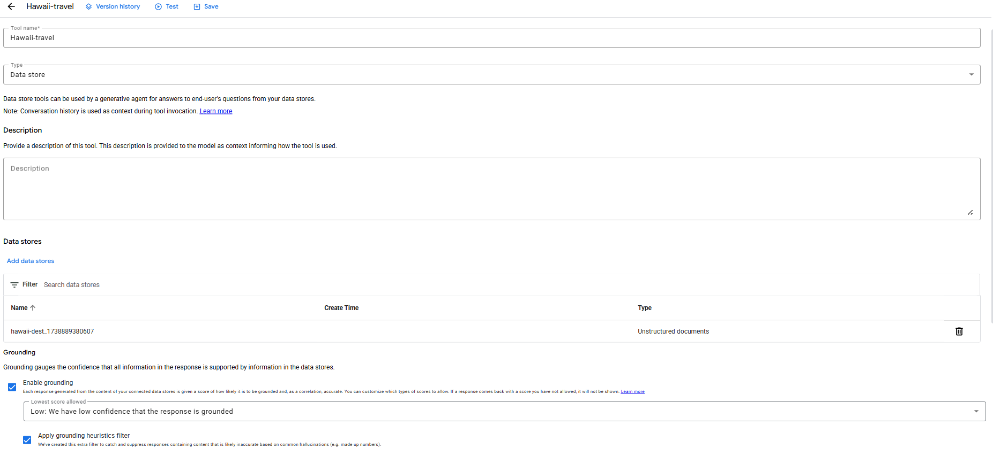

Flow Setup: This flow takes the information from the user to book tickets

Collecting information using parameter

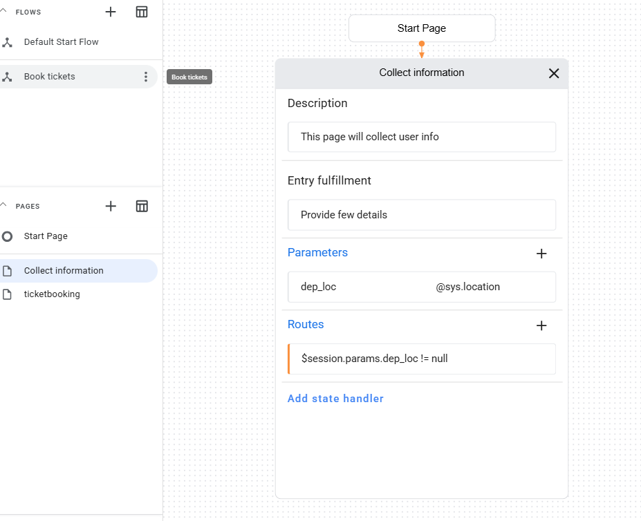

Route SetUp:

Route will be invoked using condition

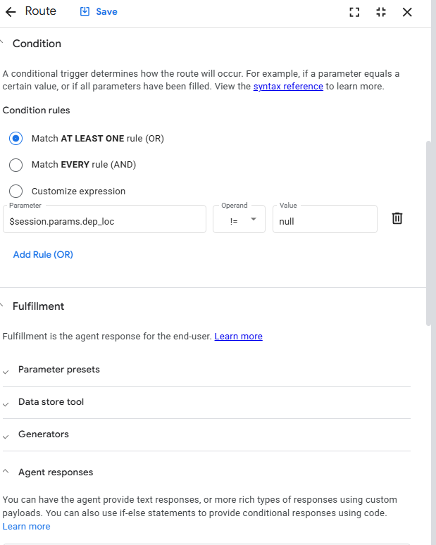

Provides agent response

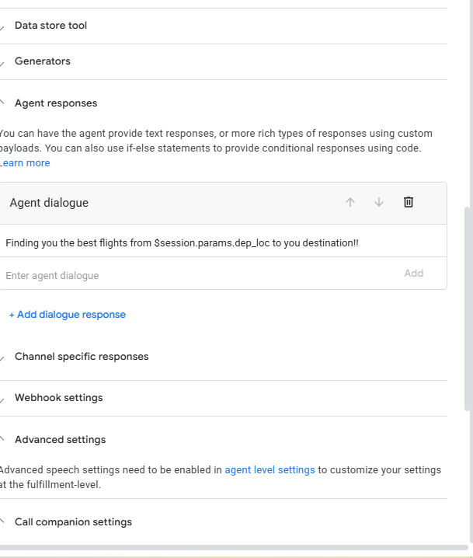

We can Further connect this to real time flight booking application using webhook and book tickets to use in the backend.